At first we think, “What a sweet boy, not selfish like many children at Christmas.”
But then we realize: “Wait a minute.”
Sharing is when you take what is important to you and give it up to some other person. This boy is not doing that. He wants two of everything so his sharing does not involve any sacrifice on his part.
Sharing is not noble unless it involves some pain on the sharer’s part. This boy wants easy sharing, without the pain.
In this example there is a lesson for all of us. For when God created the world, he apparently wanted to share himself with his creation.
Mankind was created in God’s image – God wanted to share his qualities and characteristics with us.
Then mankind rebelled.
We are a part of that rebellion, for each of us has turned our backs on God from time to time.
But Jesus still wants to share himself with us. Accomplishing this involved pain on his part. First, he gave up the glory he shared with his heavenly Father, and took on human flesh that first Christmas morning.
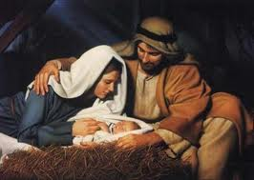
Second, during his years of ministry here on the earth, Jesus endured the criticism and attacks of the religious authorities as he shared the good news that God loves us sinners.
Most importantly, he suffered the pain of hell for us when he died in our place on the cross.

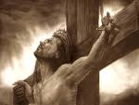

Before Jesus came to the earth, he was enjoying the security and glory of living with his Father in heaven. But to share that with us, he put it aside, put on human flesh instead. He gave 100% of himself in order to bring us the eternal life he enjoys in heaven.

God wants us to share also. He has given us 24 hours each day, 7 days each week. He wants us to give up some time each week and share that time with him. Jesus once said, “My sheep hear my voice,” and one of the best ways to do this is to regularly attend a church where Jesus’ words are taught.

God also wants us to take the love he shared with us and share it with others. There are many ways to do this. We all ought to be looking for ways to “love our neighbor as we love ourselves” as scripture teaches.

St Peter’s Lutheran Church in Mishicot invites you to come hear about the love God has for you and me and everyone on this rebellious planet we call home.

Special Christmas worship times are Dec 24 at 9:00 p.m. and Dec 25 at 9:00 a.m. Regular Sunday and Monday worship as follows:

Sundays 7:30 am and 10:00 am
Mondays 6:30 pm
http://mishicot-stpeter.org

St Peter’s Lutheran Church
325 Randolph Street
Mishicot, WI 54228-9550

A Christmas Lesson
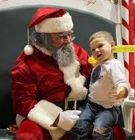
A little boy climbed on Santa’s lap, and said, “I want two footballs, two remote controlled cars, and two video game sets.”
Santa replied, “That’s a tall order. But why do you want two of everything?”
The little boy replied, “So that I can share.”

